Project Initialization and Planning Phase

Date | 15 March 2024
Team ID
Project Name | Global Malnutrition Trends: A Power BI Analysis
Maximum Marks | Marks

Define Problem Statements (Customer Problem Statement Template):

Malnutrition remains a critical global health issue, with children in lower-income countries disproportionately affected. The primary problem is to determine how various forms of malnutrition (such as stunting, wasting, underweight, and overweight) correlate with the economic and geographical classifications of countries.
The project aims to identify which countries and regions are most affected by leveraging historical data from 1983 to 2019. The analysis will highlight areas needing urgent attention and support, helping stakeholders prioritize interventions and develop targeted, data-driven solutions to improve child health outcomes worldwide.
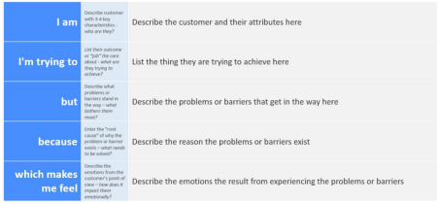
Reference: https://miro.com/templates/customer-problem-statement/
Example:
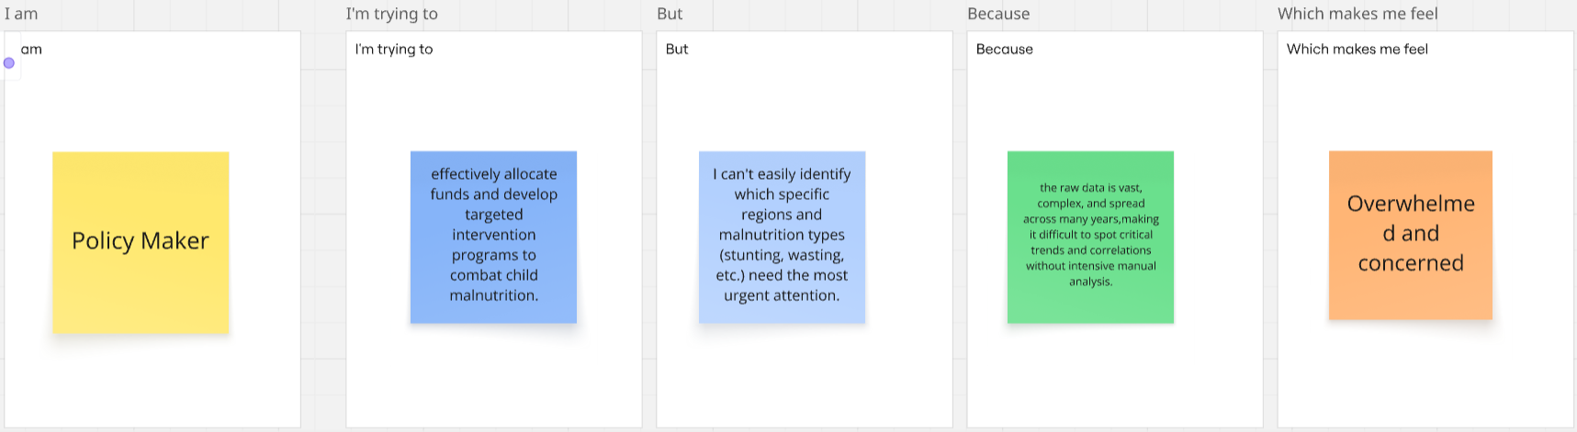

Problem  Statement (PS) | I am  (Customer) | I’m trying to | But | Because | Which makes me feel
PS-1 | a Policy Maker at a global health organization (like WHO or UNICEF). | effectively allocate funds and develop targeted intervention programs to combat child malnutrition. | I can't easily identify which specific regions and malnutrition types (stunting, wasting, etc.) need the most urgent attention. | the raw data is vast, complex, and spread across many years, making it difficult to spot critical trends and correlations without intensive manual analysis. | Overwhelmed and concerned
PS-2 | a Public Health Researcher or Data Analyst. | provide clear, data-driven recommendations to governments and NGOs on how to address child health issues | it is time-consuming to process and visualize the decades of data to find meaningful insights. | the datasets are large and require significant data cleaning and modeling before they can be used to create compelling, easy-to-understand visualizations. | Frustrated

